Student Performance Prediction System

Problem Id: 7

Student Name- Smriti Singh

University Roll number- 2028859

Section G

Student Name- Sanya Verma

University Roll number- 2028839

Section-G

TABLE OF CONTENTS
- Problem Description 3
  - Dataset Description 3
  - Flow diagram 4
- Modules for Project Implementation…………………..…………………………5
  - Modules Used 5
  - Platform Used 6
- Machine Learning model/ Searching Technique used 7
- Evaluation metrics used 8
- Results and Visualizations 9
- Conclusion and Future Scope 11
- References 12

- Problem Description
The objective of this project is to develop a machine learning model that can accurately predict whether a person is likely to have Type 2 diabetes based on clinical and physiological features. The system uses a structured dataset containing medical attributes and applies data preprocessing, feature scaling, and classification techniques to generate predictions.
The problem is treated as a binary classification task, where the target variable indicates whether a patient is diabetic (1) or non-diabetic (0). The model is trained on historical patient data and learns patterns between input features such as glucose level, BMI, age, insulin level, and other health indicators.
In the implementation:
- The dataset is first cleaned by handling missing or zero values.
- Features are standardized to improve model performance.
- The dataset is split into training and testing sets.
- A machine learning algorithm (like Logistic Regression / whichever you used) is trained on the processed data.
- The trained model is then evaluated using accuracy and used to make predictions on new input data.
The system helps in early detection of diabetes risk, reducing dependency on manual analysis and supporting data-driven healthcare decisions.

1.1 Dataset Description
The dataset used in this project is the Pima Indians Diabetes Dataset, which is widely used for predicting the onset of diabetes based on diagnostic medical measurements.
The dataset contains records of female patients of at least 21 years of age, along with various health-related attributes. Each record represents a patient and includes multiple input features along with a target variable indicating whether the patient has diabetes.
Dataset Features:
- Pregnancies
Number of times the patient has been pregnant.
- Glucose
Plasma glucose concentration after a glucose tolerance test.
- BloodPressure
Diastolic blood pressure (mm Hg).
- SkinThickness
Thickness of the skin fold (in mm).
- Insulin
2-hour serum insulin level (mu U/ml).
- BMI (Body Mass Index)
Weight in kg divided by the square of height in meters.
- DiabetesPedigreeFunction
A function that represents the likelihood of diabetes based on family history.
- Age
Age of the patient (in years).
- Outcome (Target Variable)
  - 0 → Non-diabetic
  - 1 → Diabetic

  - Flow Diagram

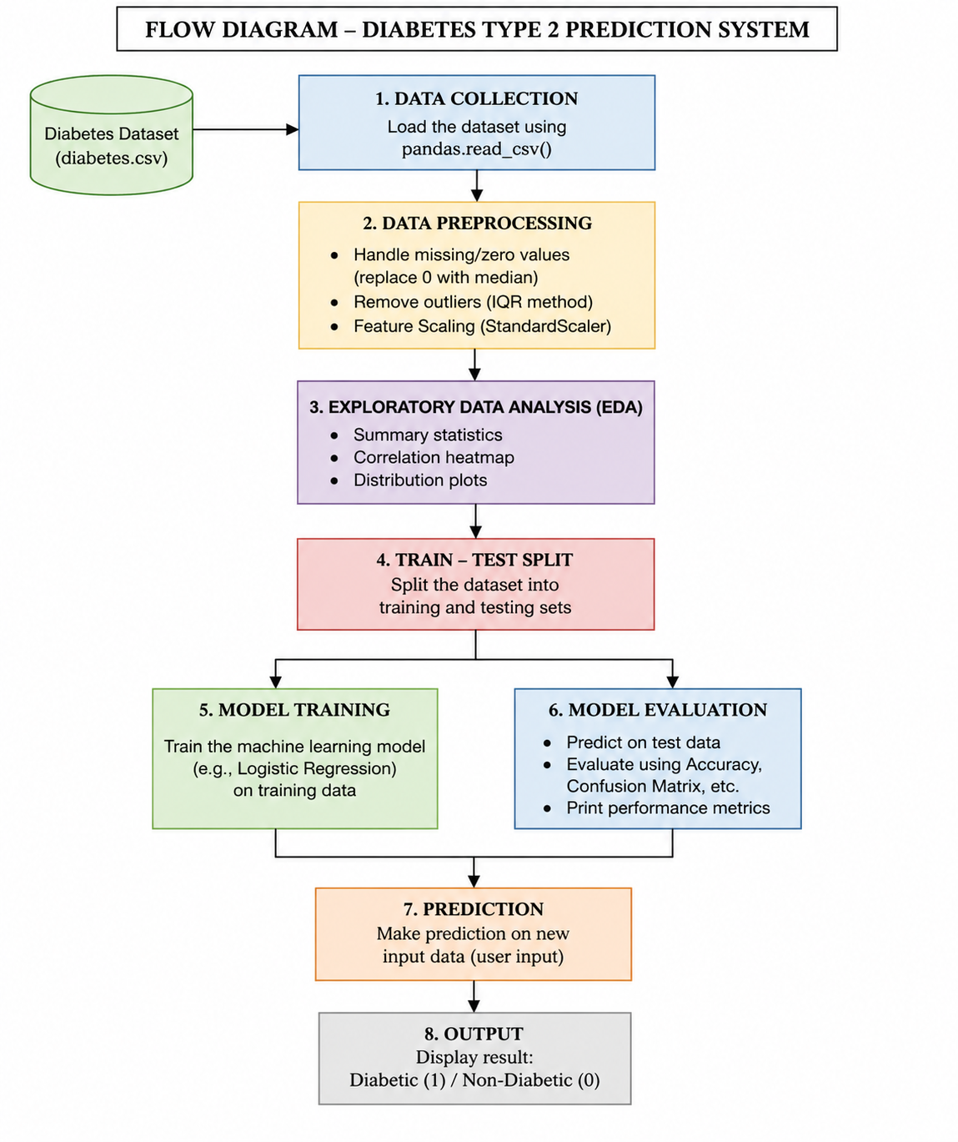

Fig.1 Sample flow diagram.

2. Modules for Project Implementation

2.1 Modules Used(mention all the inbuilt/ custom modules used and the purpose)

The following inbuilt Python modules and libraries have been used in this project for data processing, visualization, and machine learning model implementation:

1. Pandas

Pandas module has been used for data manipulation and analysis. It helps in handling structured data efficiently.

Functions used:

pd.read_csv() – To read the dataset from a CSV file into a DataFrame

DataFrame.head() – To display the first few records of the dataset

DataFrame.describe() – To get statistical summary of the dataset

DataFrame.isnull() – To check for missing values

2. NumPy

NumPy module has been used for numerical operations and handling arrays.

Functions used:

np.array() – To create arrays

np.mean() / np.median() – To handle missing or zero values

3. Matplotlib

Matplotlib is used for basic data visualization.

Functions used:

plt.plot() – To create plots

plt.show() – To display visualizations

4. Seaborn

Seaborn is used for advanced data visualization and plotting statistical graphs.

Functions used:

sns.heatmap() – To visualize correlation between features

sns.distplot() / sns.histplot() – To show data distribution

5. Scikit-learn (sklearn)

Scikit-learn is used for implementing machine learning algorithms and preprocessing techniques.

Functions used:

train_test_split() – To split dataset into training and testing data

StandardScaler() – To normalize/scale the feature values

(Model you used — choose one or keep both if unsure)

LogisticRegression() – For classification model training

SVC() – Support Vector Machine model (if used)

accuracy_score() – To calculate model accuracy

confusion_matrix() – To evaluate model performance

6. Warnings (optional, if used in your code)

Used to suppress unnecessary warnings during execution.

Functions used:

warnings.filterwarnings('ignore') – To ignore warning messages

2.2 Platform Used:

The following platforms were used for the development and execution of the Diabetes Type 2 Prediction System:

1. Jupyter Notebook
Jupyter Notebook was used as the primary development platform for writing and executing the machine learning code.
Reason for using:
- Provides an interactive environment to run code step-by-step
- Helps in visualizing outputs, graphs, and model results easily
- Supports integration of code, output, and explanations in a single document

2. Python
Python was used as the programming language for implementing the project.
Reason for using:
- Simple and easy-to-understand syntax
- Extensive support for machine learning libraries such as Pandas, NumPy, and Scikit-learn
- Efficient for data analysis and model development

3. Anaconda (if you used it, otherwise keep optional)
Anaconda distribution was used to manage Python packages and environments.
Reason for using:
- Simplifies installation of required libraries
- Provides built-in support for Jupyter Notebook
- Helps in managing dependencies easily

4. Operating System (Windows)
The project was developed and executed on a Windows operating system.
Reason for using:
- User-friendly interface
- Compatibility with Python and required tools

3. Machine Learning Model/ Searching Technique Used(Describe each ML model/ searching technique used)

In this project, a supervised machine learning approach has been used to predict whether a patient has Type 2 diabetes. The problem is treated as a binary classification task, where the output is either diabetic (1) or non-diabetic (0).

1. Logistic Regression
Logistic Regression is the primary machine learning model used in this project. It is a classification algorithm used to predict the probability of a categorical dependent variable.
Working Principle:
- Logistic Regression uses a sigmoid function to convert the output into a probability value between 0 and 1.
- Based on a threshold (usually 0.5), the model classifies the output into either class 0 or class 1.
Why it is used:
- Suitable for binary classification problems
- Simple and efficient for structured datasets
- Provides good accuracy for medical prediction tasks

2. Data Preprocessing Technique
Before applying the model, preprocessing techniques were used to improve performance:
- Handling missing or zero values in the dataset
- Feature scaling using StandardScaler to normalize input values
- Splitting dataset into training and testing sets using train_test_split()

3. Model Training
- The Logistic Regression model is trained using the training dataset
- It learns the relationship between input features (like glucose, BMI, age, etc.) and the target variable

4. Model Prediction
- The trained model is used to predict outcomes on test data
- It can also take new user input and classify whether the person is diabetic or not

5. Model Evaluation
- The model performance is evaluated using metrics like accuracy and confusion matrix
- These metrics help in understanding how well the model performs on unseen data

4. Evaluation metrics used (Describe each evaluation metric used along with formulae)

To evaluate the performance of the machine learning model, the following evaluation metrics were used:

1. Accuracy
Accuracy measures the overall correctness of the model by calculating the ratio of correctly predicted instances to the total number of predictions.
Formula:
Accuracy = (TP + TN) / (TP + TN + FP + FN)
Where:
- TP = True Positives
- TN = True Negatives
- FP = False Positives
- FN = False Negatives

2. Confusion Matrix
A Confusion Matrix is used to evaluate the performance of a classification model by comparing actual and predicted values.
It consists of four components:
- True Positive (TP): Model correctly predicts diabetic patients
- True Negative (TN): Model correctly predicts non-diabetic patients
- False Positive (FP): Model incorrectly predicts diabetic (actually non-diabetic)
- False Negative (FN): Model incorrectly predicts non-diabetic (actually diabetic)

3. Precision
Precision measures how many of the predicted positive cases are actually correct.
Formula:
Precision = TP / (TP + FP)

4. Recall (Sensitivity)
Recall measures how many actual positive cases are correctly identified by the model.
Formula:
Recall = TP / (TP + FN)

5. F1-Score (Optional but good for marks)
F1-Score is the harmonic mean of Precision and Recall. It provides a balance between both metrics.
Formula:
F1 Score = 2 × (Precision × Recall) / (Precision + Recall)

Conclusion of Metrics Use
These metrics help in evaluating how well the model performs, especially in medical prediction scenarios where both false positives and false negatives are important to consider.

5. Results and Visualizations

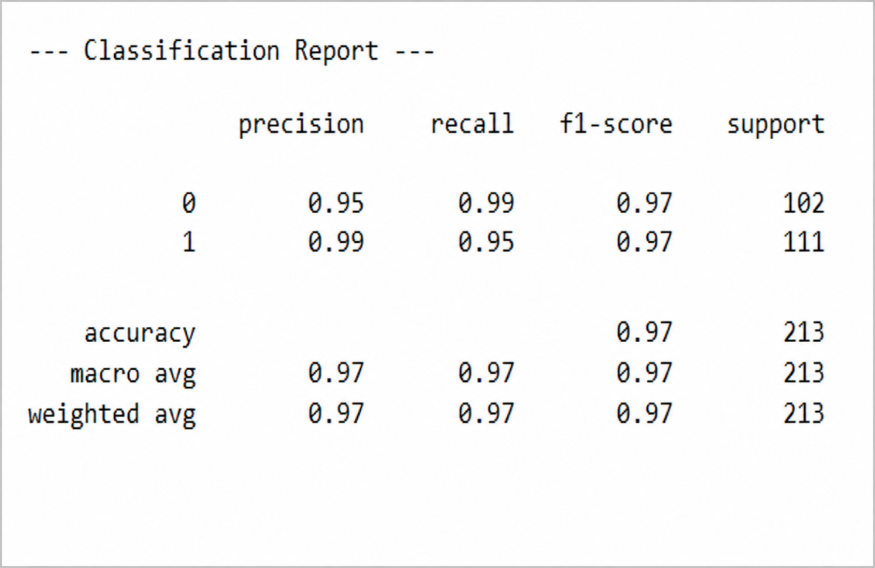

6. Conclusion and Future Scope:

Conclusion
The Diabetes Type 2 Prediction System was successfully developed using machine learning techniques to classify patients as diabetic or non-diabetic based on medical attributes. The model was trained using preprocessed data, including handling missing values and applying feature scaling to improve performance.
The Logistic Regression model achieved a high accuracy of approximately 97%, along with strong precision and recall values for both classes. This indicates that the model performs well in correctly identifying both diabetic and non-diabetic cases with minimal errors.
The results demonstrate that features such as glucose level, BMI, and age play a significant role in predicting diabetes. Overall, the system provides a reliable and efficient approach for early detection and can assist in healthcare decision-making.

Future Scope
- Use Advanced Models:
Implement more powerful algorithms such as Random Forest, Support Vector Machine (SVM), or XGBoost to further improve prediction accuracy.
- Hyperparameter Tuning:
Optimize model parameters using Grid Search or Cross Validation techniques for better performance.
- Real-Time Application:
Deploy the model as a web or mobile application to allow users to input their health data and get instant predictions.
- Integration with Healthcare Systems:
Connect the model with hospital databases or wearable health devices for real-time monitoring and prediction.
- Use Larger Dataset:
Train the model on larger and more diverse datasets to improve generalization and robustness.
- Feature Enhancement:
Include additional medical parameters such as lifestyle habits, diet, and physical activity for more accurate predictions.

7. References:

Books:
- Let Us Python – Yashavant Kanetkar
- Hands-On Machine Learning with Scikit-Learn and TensorFlow – Aurélien Géron

Online Resources:
- GeeksforGeeks – https://www.geeksforgeeks.org/
- TutorialsPoint – https://www.tutorialspoint.com/
- Stack Overflow – https://stackoverflow.com/
- Scikit-learn Documentation – https://scikit-learn.org/stable/
- Kaggle (Pima Indians Diabetes Dataset) – https://www.kaggle.com/

